# Create Table

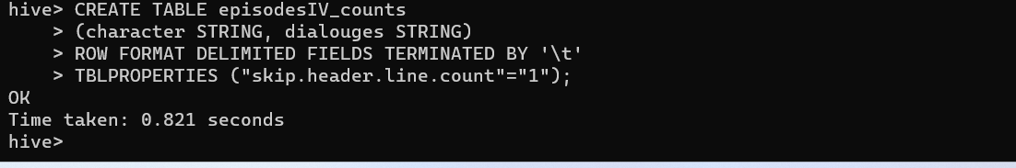

# Load File in table

LOAD DATA LOCAL INPATH '/episodeIV_dialouges.txt' INTO TABLE episodesIV_counts;



# Exports to HDFS directory

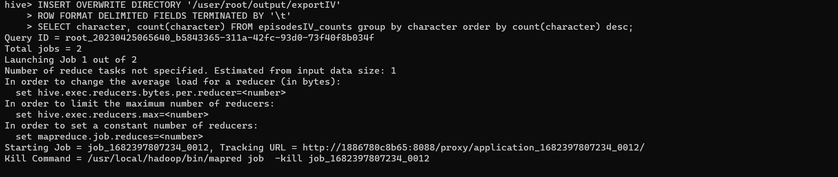

Job ended Results:

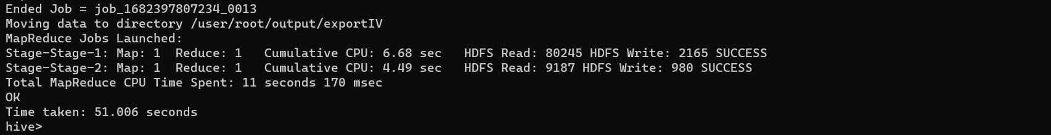

Output stored at Hdfs :

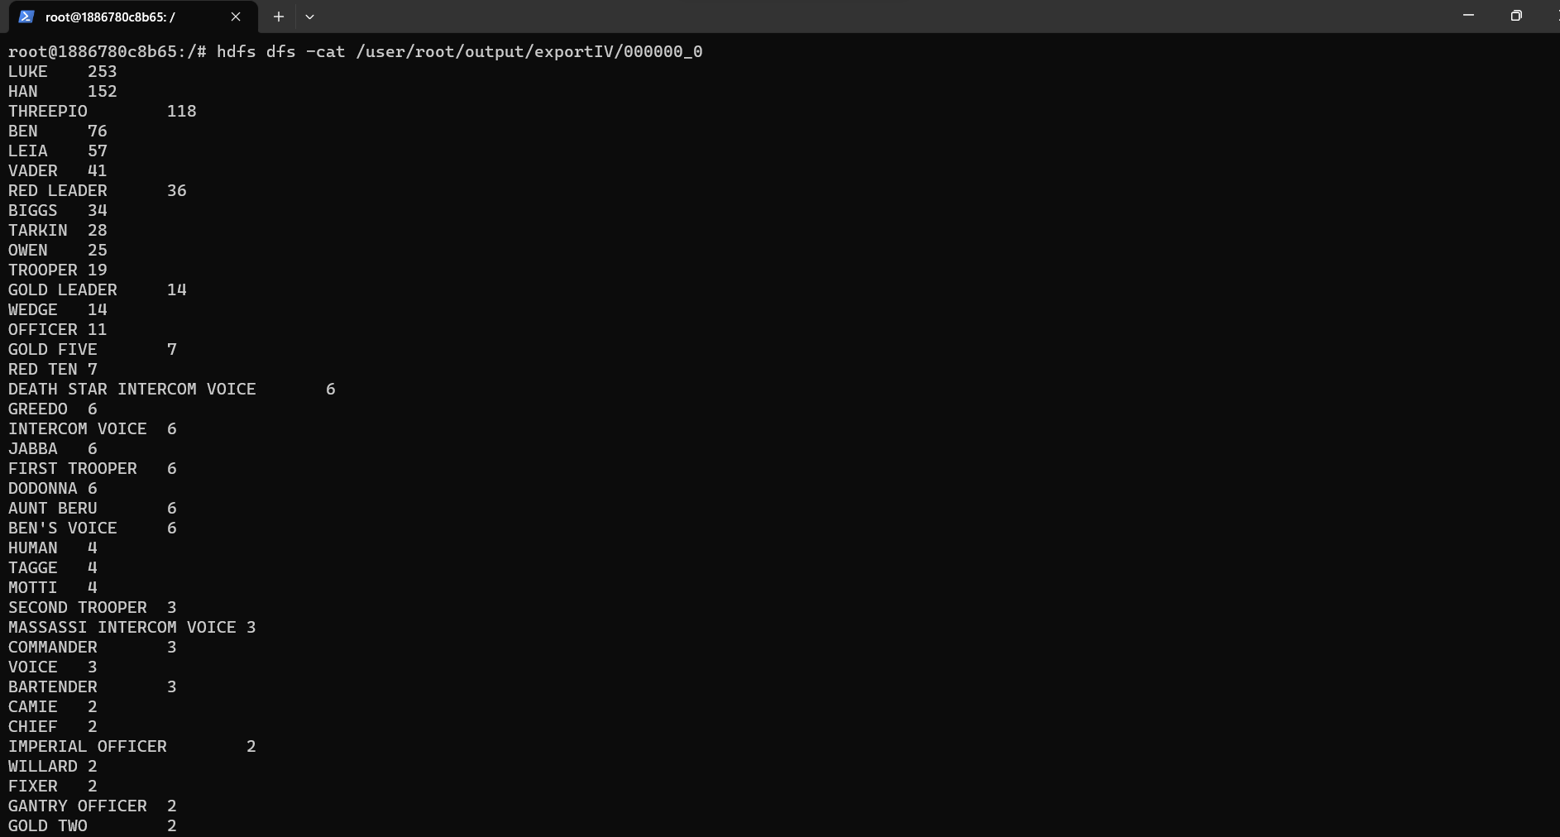

#check results in local

hdfs dfs -get /user/root/output/exportIV/000000_0 /episodeIV/hiveResult

cat /episodeIV/hiveResult/000000_0

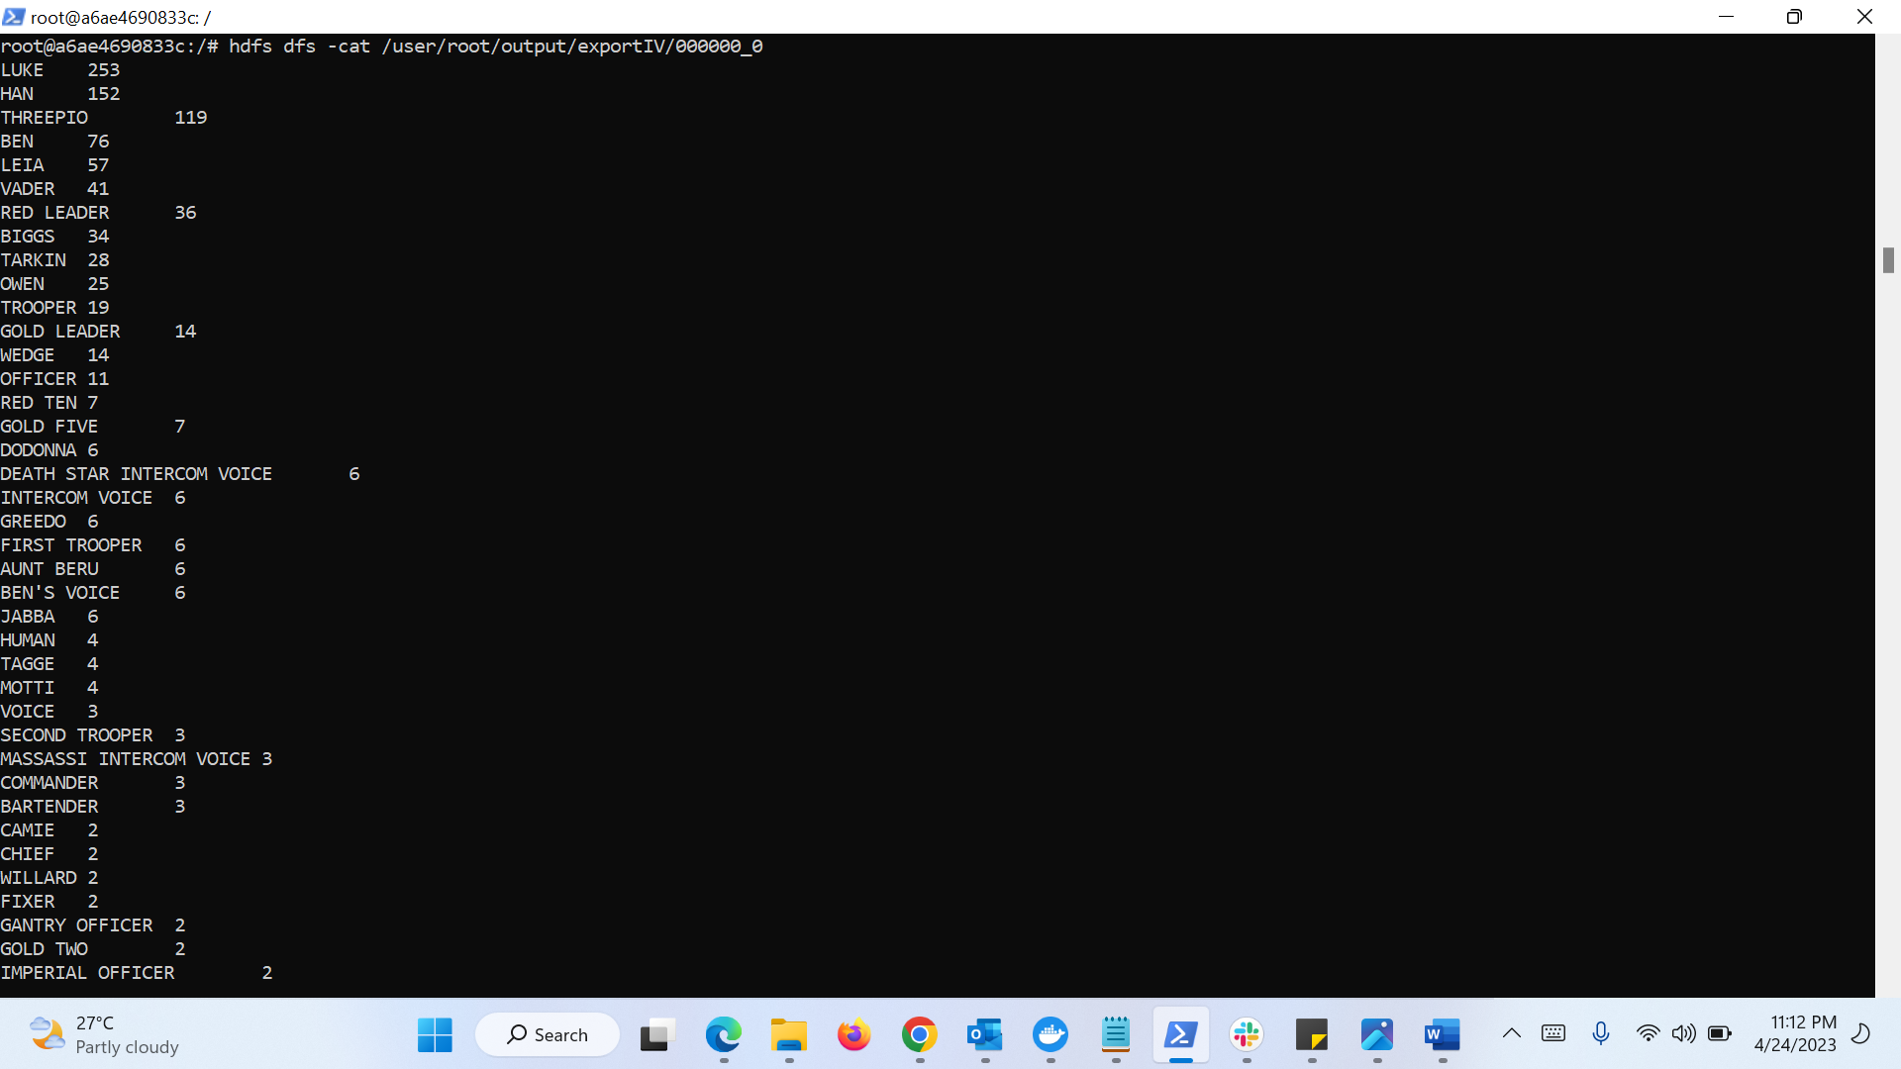

**Episode 5**

#create table

hive> CREATE TABLE episodesV_counts

> (character STRING, dialouges STRING)

> ROW FORMAT DELIMITED FIELDS TERMINATED BY '\t'

> TBLPROPERTIES ("skip.header.line.count"="1");

#load data

hive> LOAD DATA LOCAL INPATH

> '/episodeV_dialouges.txt'

> INTO TABLE episodesV_counts;

#Exports to HDFS directory

hive> INSERT OVERWRITE DIRECTORY '/user/root/output/exportV'

> ROW FORMAT DELIMITED FIELDS TERMINATED BY '\t'

> SELECT character, count(character) FROM episodesV_counts group by character order by count(character) desc;

#check results in HDFS

hdfs dfs -cat /user/root/output/exportV/000000_0

#check results in local

hdfs dfs -get /user/root/output/exportV/000000_0 /episodeV/hiveResult

cat /episodeV/hiveResult/000000_0

Episode 5 results in HDFS

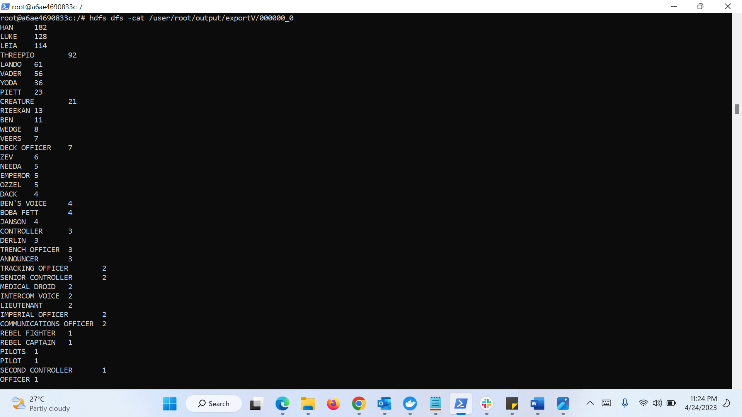

Episode 5 results in Local

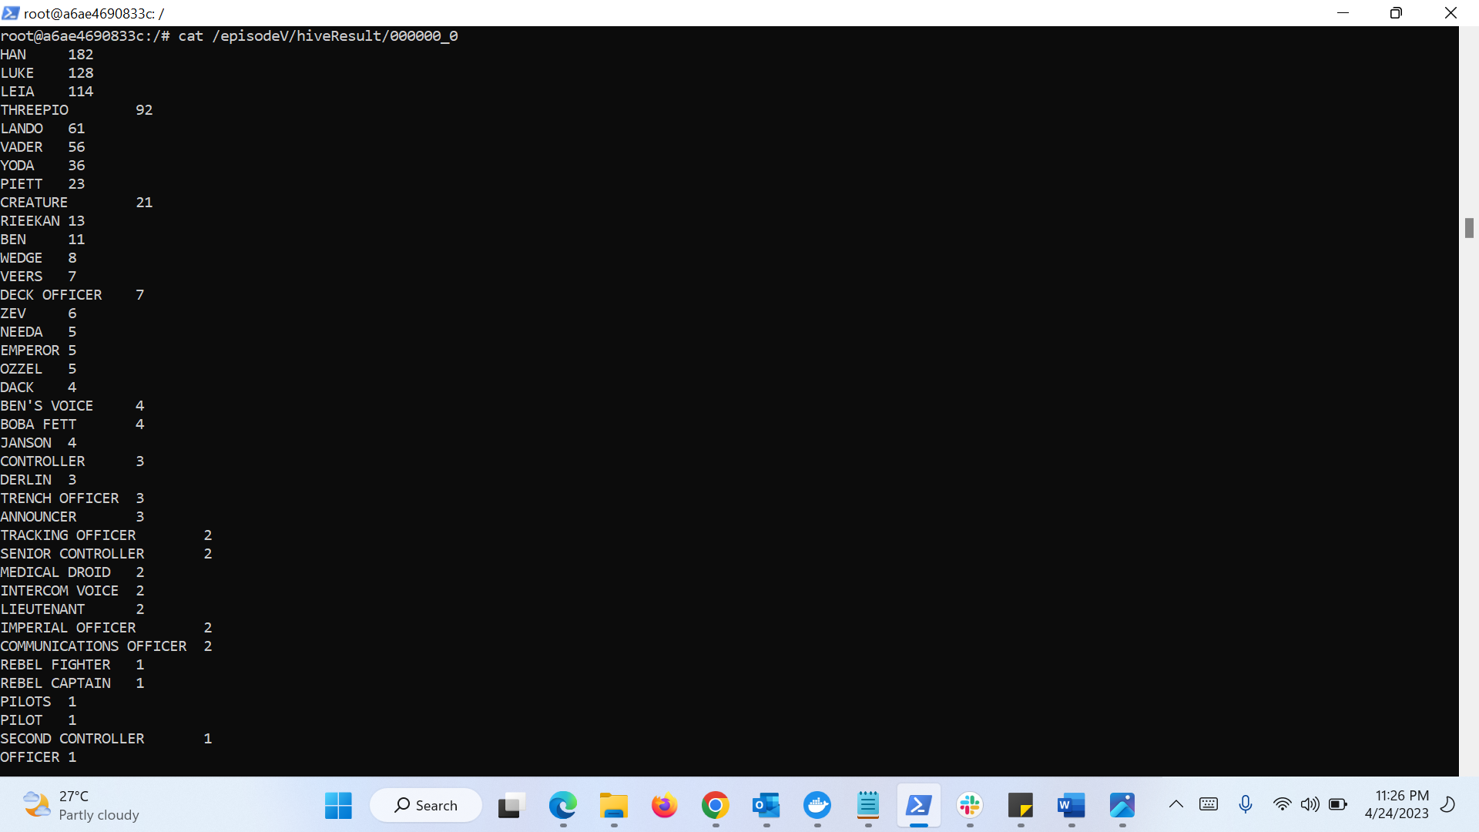

#create table

hive> CREATE TABLE episodesVI_counts

> (character STRING, dialouges STRING)

> ROW FORMAT DELIMITED FIELDS TERMINATED BY '\t'

> TBLPROPERTIES ("skip.header.line.count"="1");

#load data

hive> LOAD DATA LOCAL INPATH

> '/shrikant/episodeVI_dialouges.txt'

> INTO TABLE episodesVI_counts;

#Exports to HDFS directory

hive> INSERT OVERWRITE DIRECTORY '/user/root/output/exportVI'

> ROW FORMAT DELIMITED FIELDS TERMINATED BY '\t'

> SELECT character, count(character) FROM episodesVI_counts group by character order by count(character) desc;

#check results in HDFS

hdfs dfs -cat /user/root/output/exportVI/000000_0

#check results in local

hdfs dfs -get /user/root/output/exportVI/000000_0 /episodeVI/hiveResult

cat /episodeVI/hiveResult/000000_0

Episode 6 results in HDFS

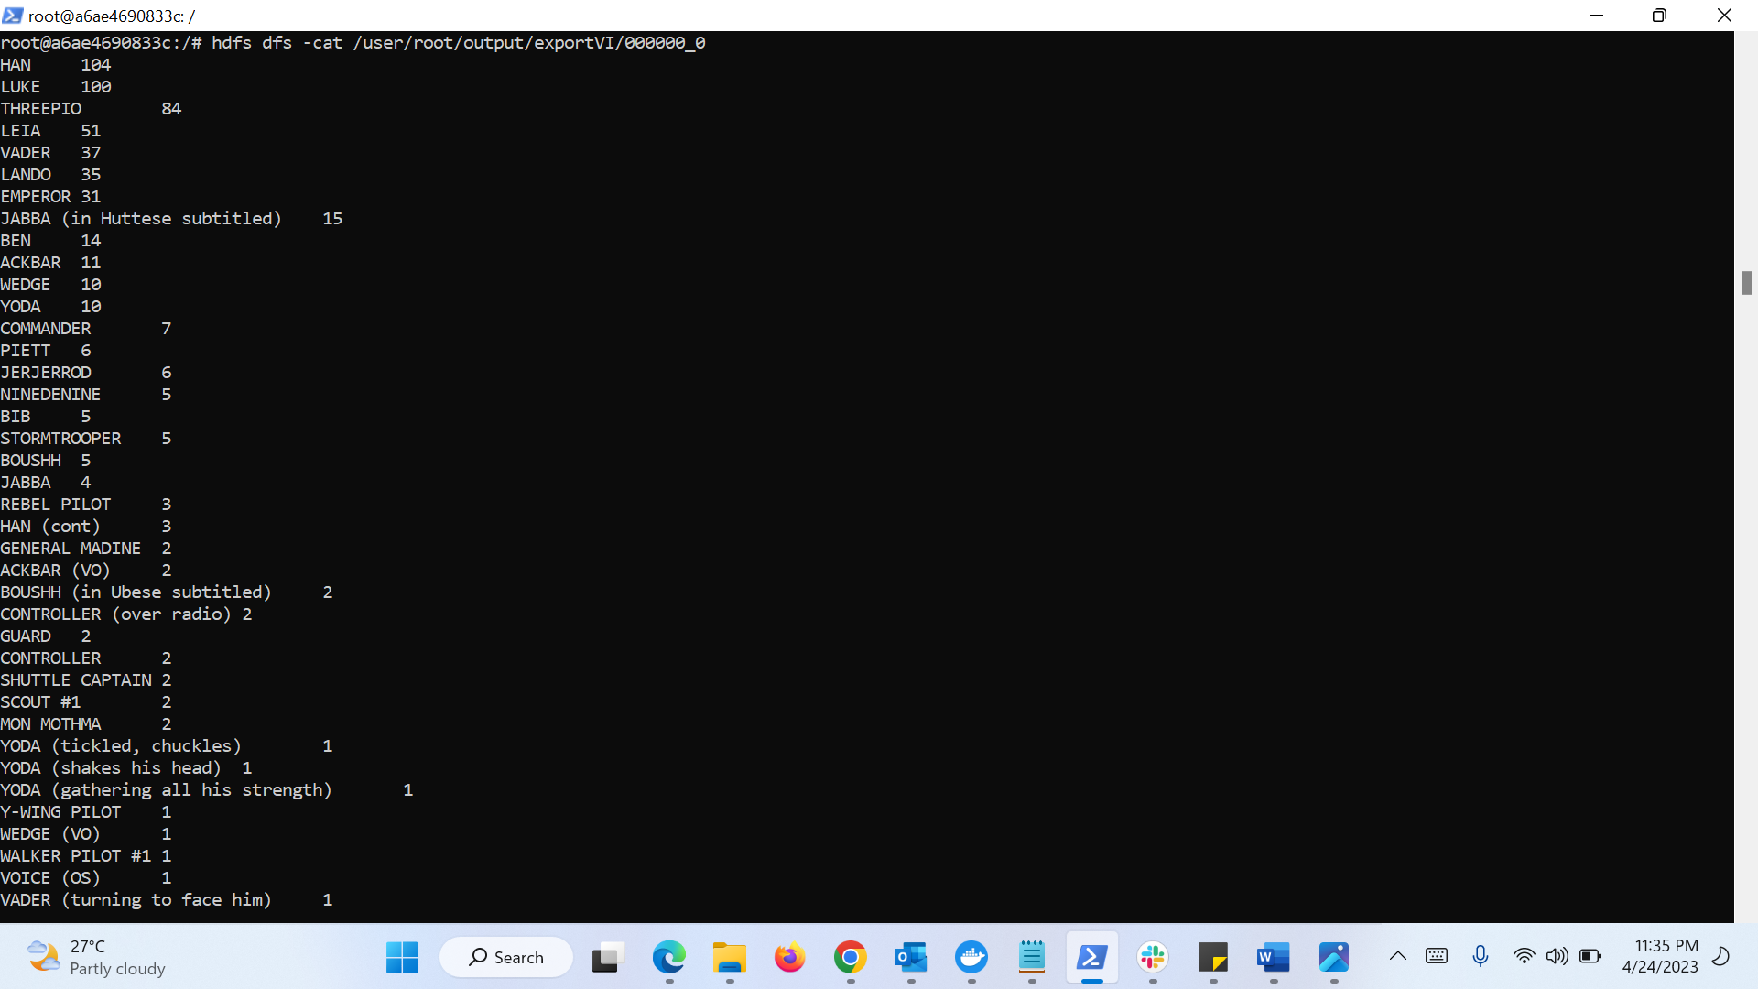

Episode 6 results in Local

